Name: Zouyan Song

Title: LAB2

Course number: EE450

Abstract:

* This lab explores the fundamentals of Ethernet and Address Resolution Protocol (ARP) through hands-on packet capture and analysis using Wireshark. By capturing and analyzing real internet traffic, we could gain practical insights into link-layer addressing, protocol encapsulation, and the critical role of ARP in mapping IP addresses to MAC addresses.

**\***: Lab results is based on the packet trace file (*ethernet-wireshark-trace1*) provided by the author from <http://gaia.cs.umass.edu/wireshark-labs/wireshark-traces-8.1.zip>).

1. What is the 48-bit Ethernet address of your computer?

* The 48-bit Ethernet address is: **c4:41:1e:75:b1:52**

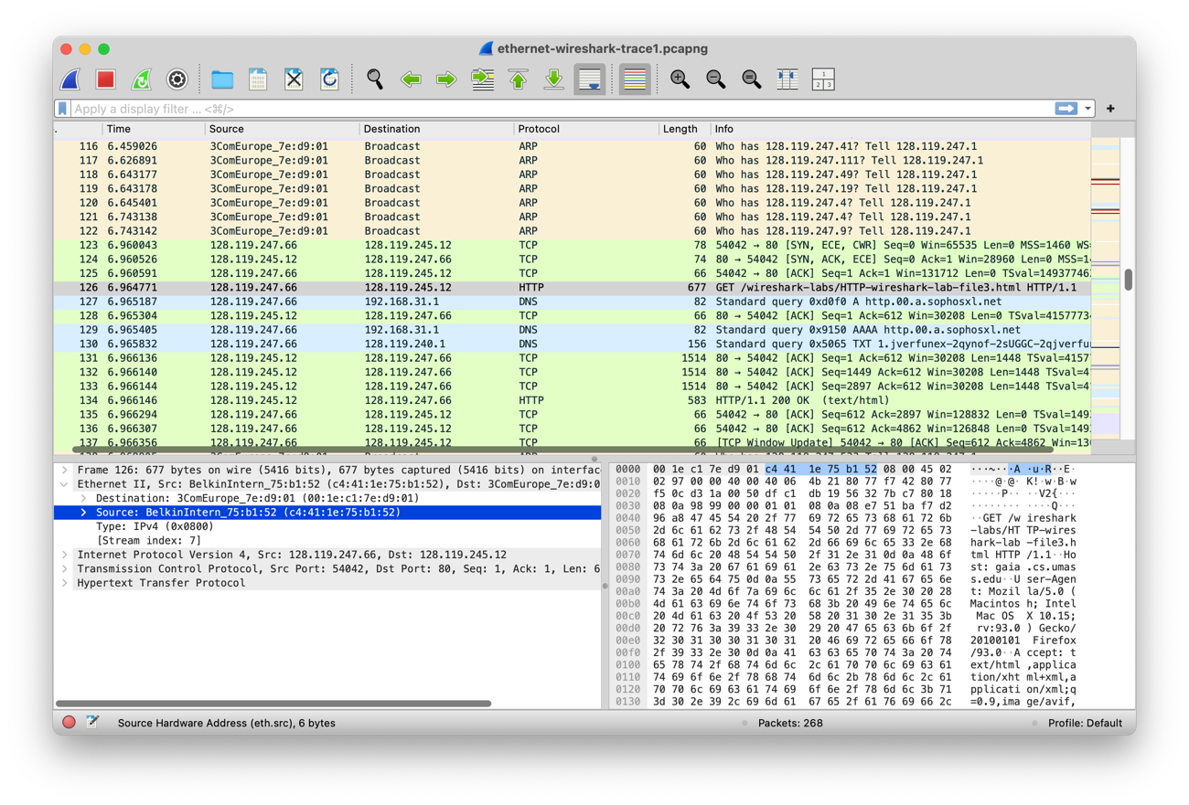

2. What is the 48-bit destination address in the Ethernet frame? Is this the Ethernet address of gaia.cs.umass.edu? What device has this as its Ethernet address?

* The destination address is **00:1e:c1:7e:d9:01**

This is **NOT** the Ethernet address of *gaia.cs.umass.edu*, instead, this is the address of the router (internet gateway) which the host is connected to.

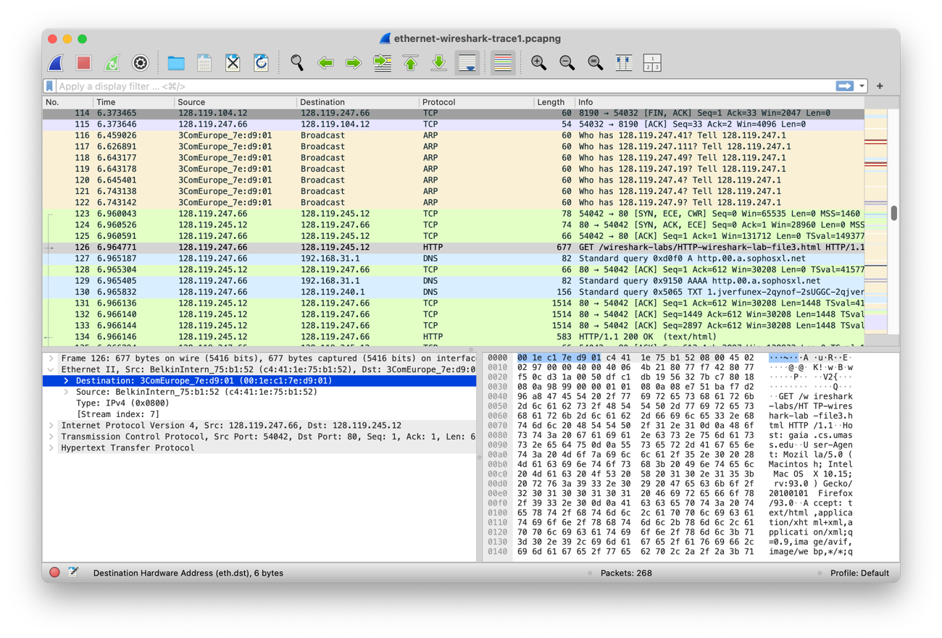

3. What is the hexadecimal value for the two-byte Frame type field in the Ethernet frame carrying the HTTP GET request? What upper layer protocol does this correspond to?

* The hexadecimal value is **0x0800**, which corresponds to **IPv4** protocol.

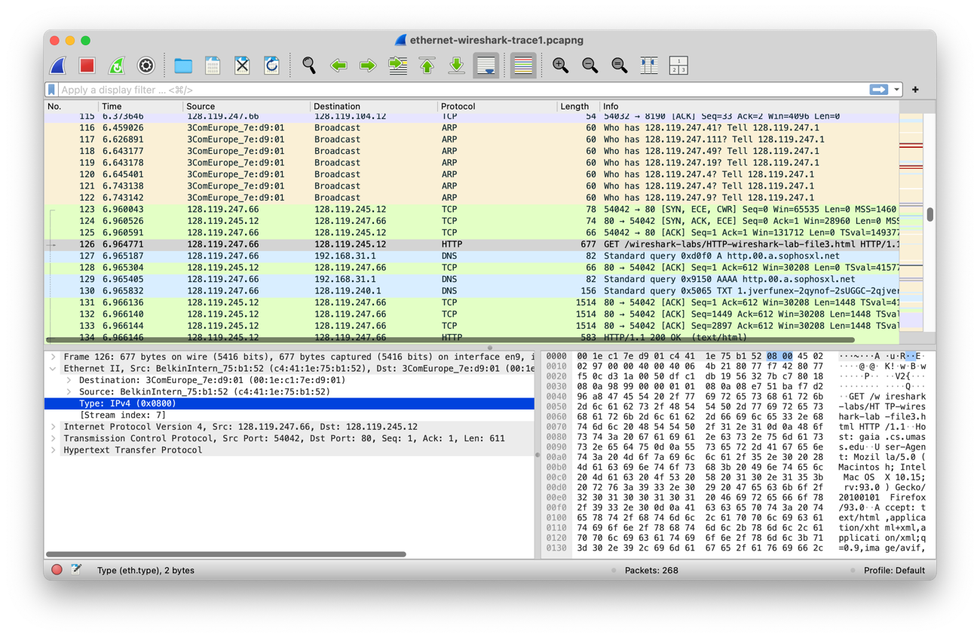

4. How many bytes from the very start of the Ethernet frame does the ASCII “G” in “GET” appear in the Ethernet frame? Do not count any preamble bits in your count, i.e., assume that the Ethernet frame begins with the Ethernet frame's destination address.

* The ASCII “G” in “GET” appears **67 bits** from the very start of the Ethernet frame.

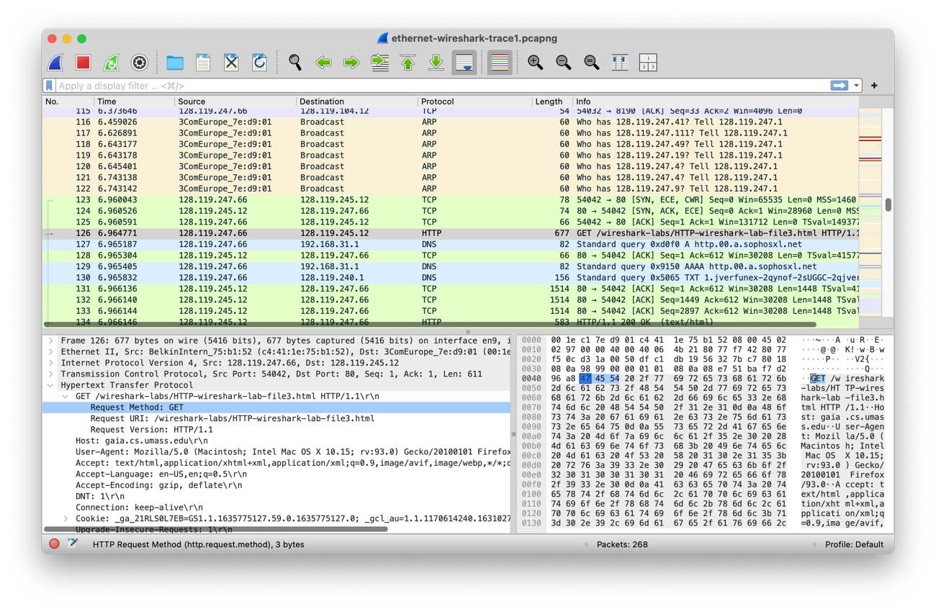

5. What is the value of the Ethernet source address? Is this the address of your computer, or of gaia.cs.umass.edu. What device has this as its Ethernet address?

* The value of the Ethernet source address is **00:1e:c1:7e:d9:01**,

This is **NOT** the Ethernet address of user’s computer or *gaia.cs.umass.edu*, instead, this is the address of the router (internet gateway) which the user is connected to.

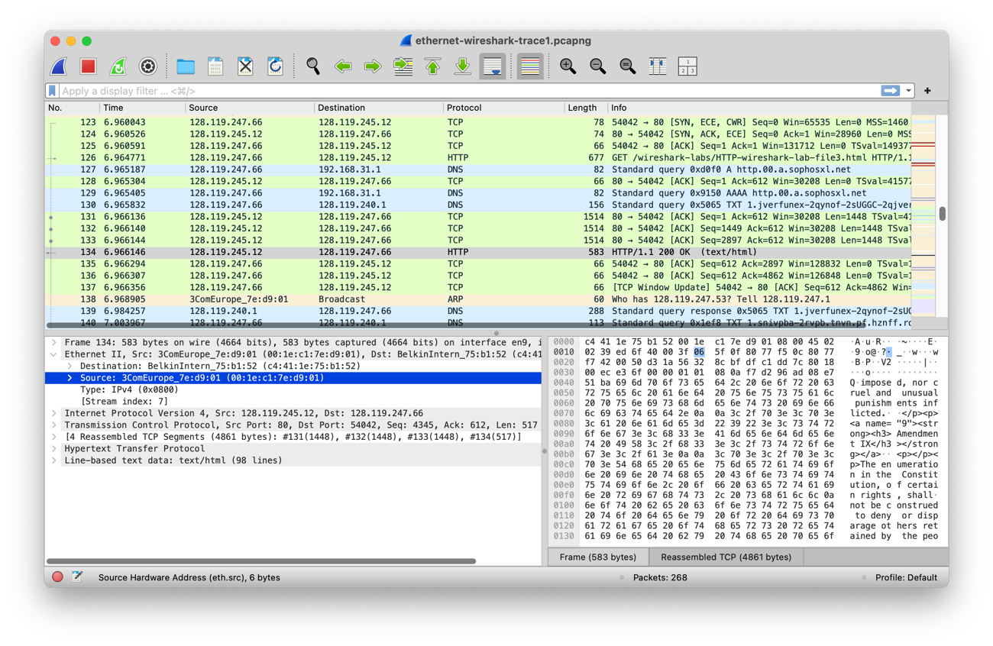

6. What is the destination address in the Ethernet frame? Is this the Ethernet address of your computer?

* The destination address is **c4:41:1e:75:b1:52**, this **is** the address of user’s computer.

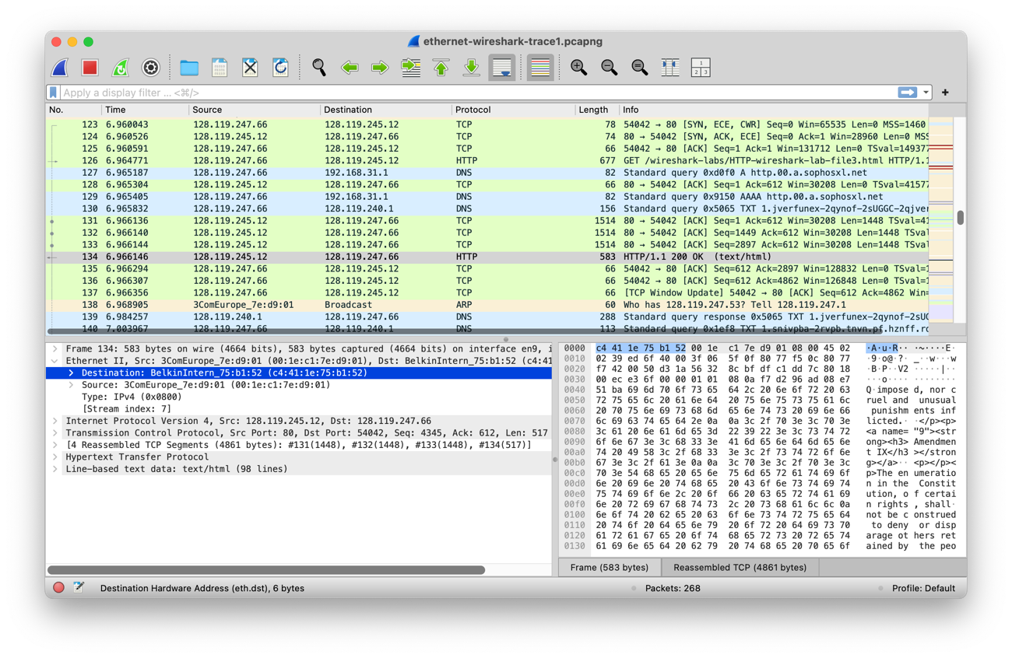

7. Give the hexadecimal value for the two-byte Frame type field. What upper layer protocol does this correspond to?

* The hexadecimal value is **0x0800**, which corresponds to **IPv4** protocol.

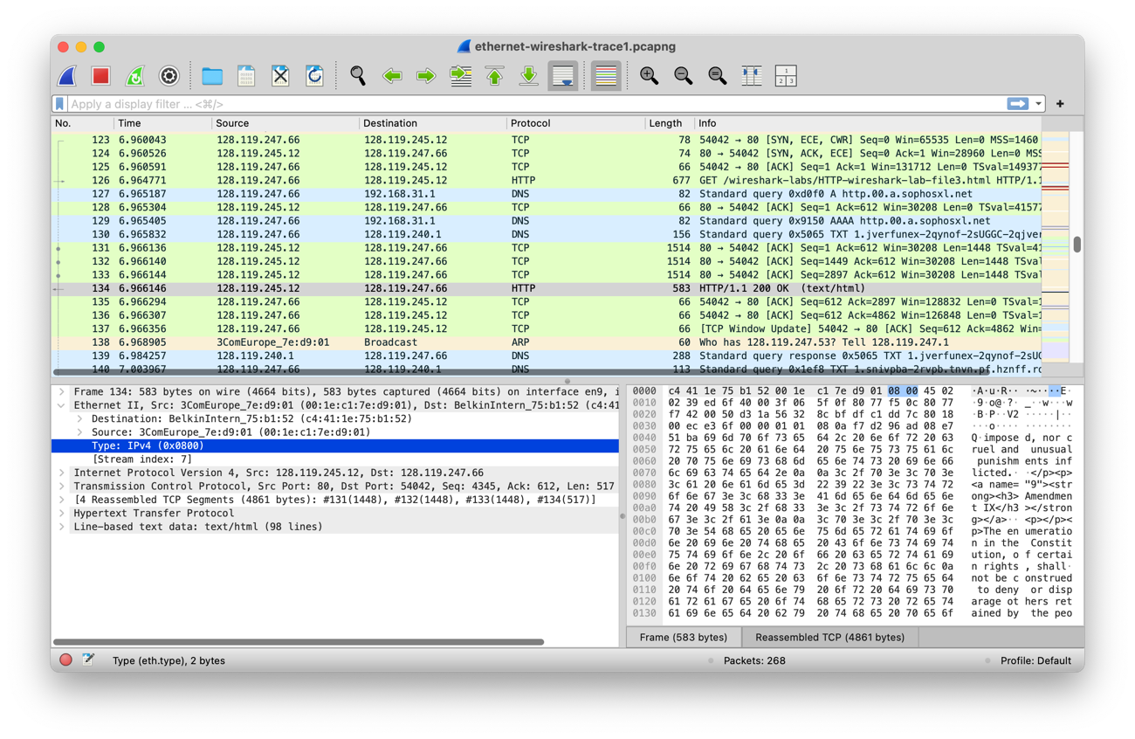

8. How many bytes from the very start of the Ethernet frame does the ASCII “O” in “OK” (i.e., the HTTP response code) appear in the Ethernet frame? Do not count any preamble bits in your count, i.e., assume that the Ethernet frame begins with the Ethernet frame's destination address.

* The ASCII “O” in “OK” appears **14 bits** from the very start of the Ethernet frame.

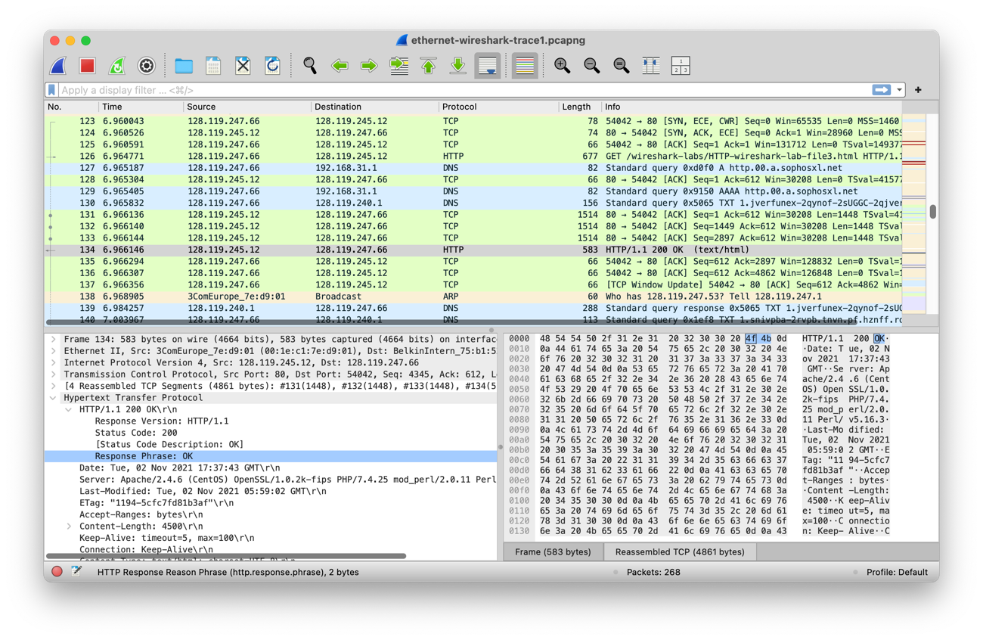

9. How many Ethernet frames (each containing an IP datagram, each containing a TCP segment) carry data that is part of the complete HTTP “OK 200 ...” reply message?

* **4 Ethernet frames** (#131, #132, # 133, #134)

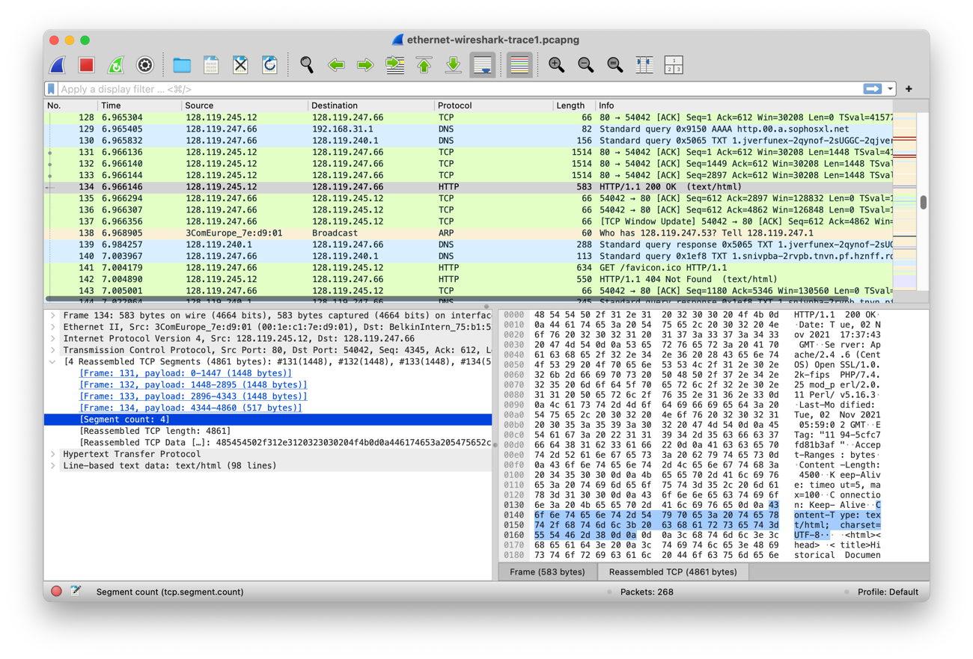

10. How many entries are stored in your ARP cache?

* There are **3 entries** stored in my ARP cache

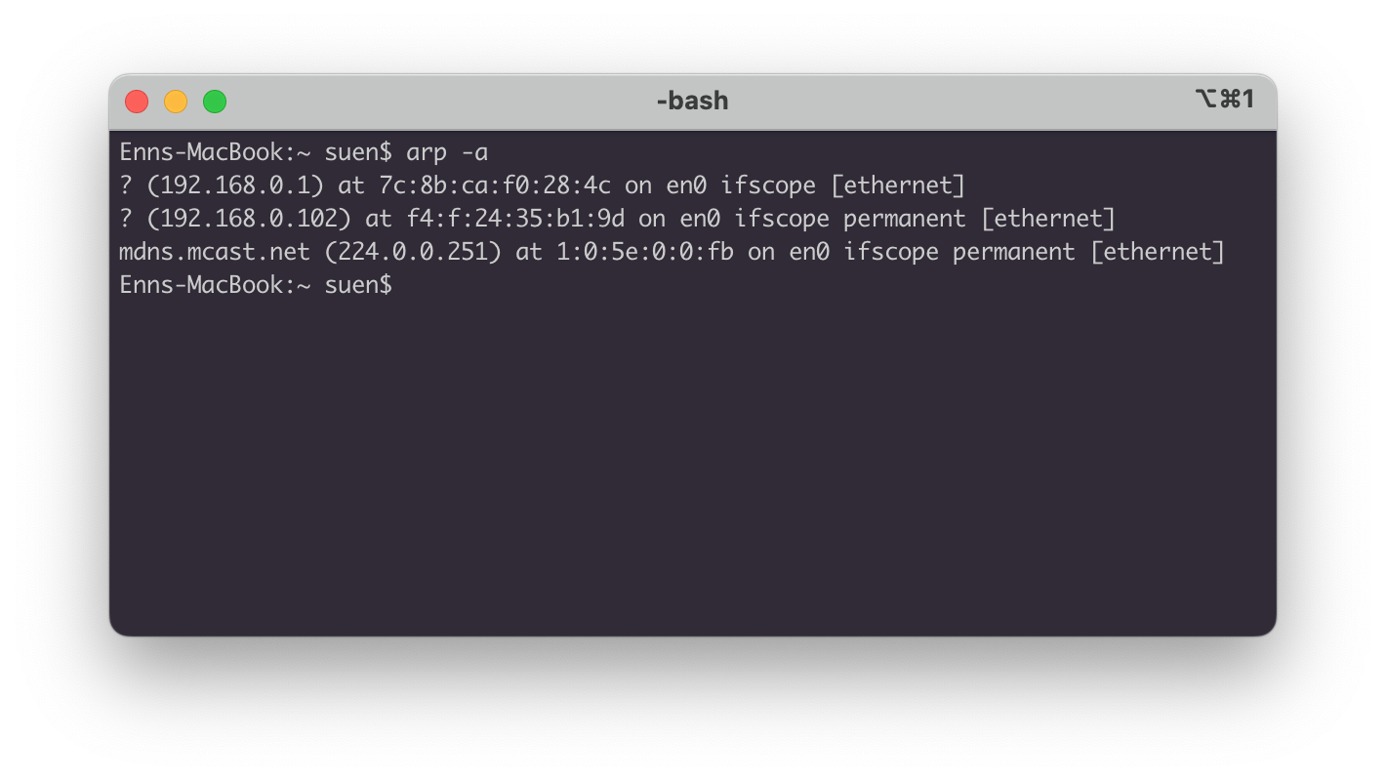

11. What is contained in each displayed entry of the ARP cache?

* Each entry contains: **Domain**, **IP address** (IPv4), **MAC address**, **network interface**, **protocol type** (dynamic / static(=permanent)).



12. What is the hexadecimal value of the source address in the Ethernet frame containing

the ARP request message sent out by your computer?

* The source address is: **c4:41:1e:75:b1:52**

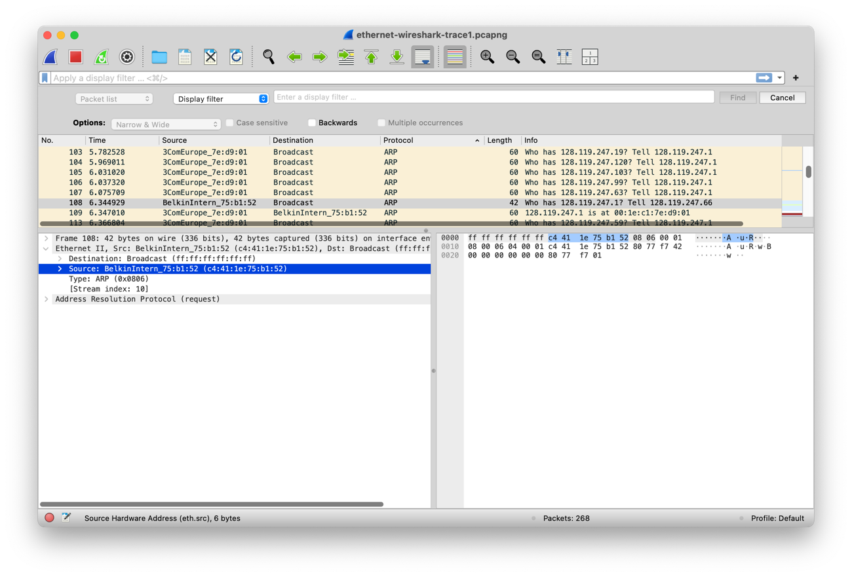

13. What is the hexadecimal value of the destination addresses in the Ethernet frame containing the ARP request message sent out by your computer? And what device(if any) corresponds to that address (e.g,, client, server, router, switch or otherwise...)?

* The destination addresses is **ff:ff:ff:ff:ff:ff** (Broadcast address).

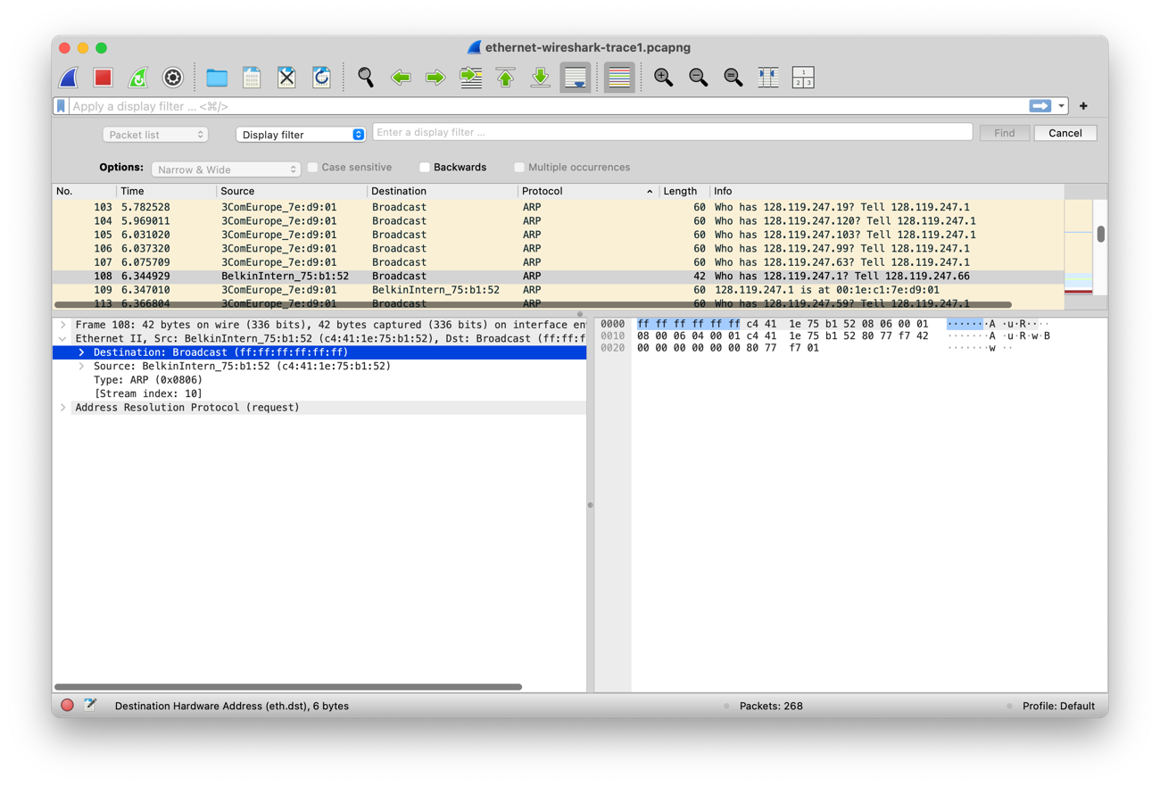

14. What is the hexadecimal value for the two-byte Ethernet Frame type field. What upper layer protocol does this correspond to?

* The hexadecimal value is **0x0806**, which corresponds to **ARP** protocol.

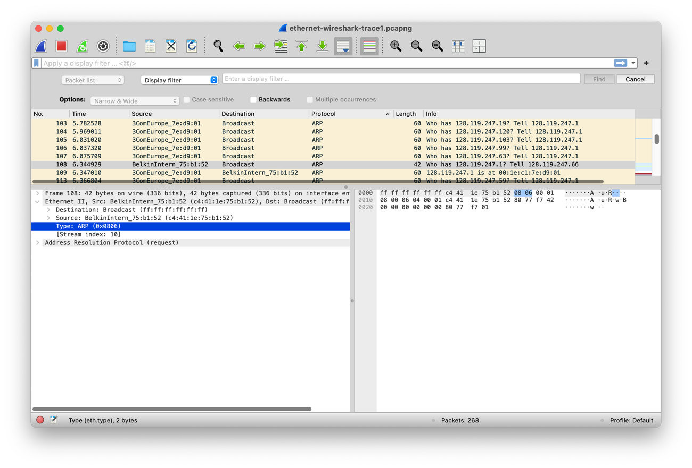

15. How many bytes from the very beginning of the Ethernet frame does the ARP opcode field begin?

* **20 bytes** from the very beginning of the Ethernet frame.

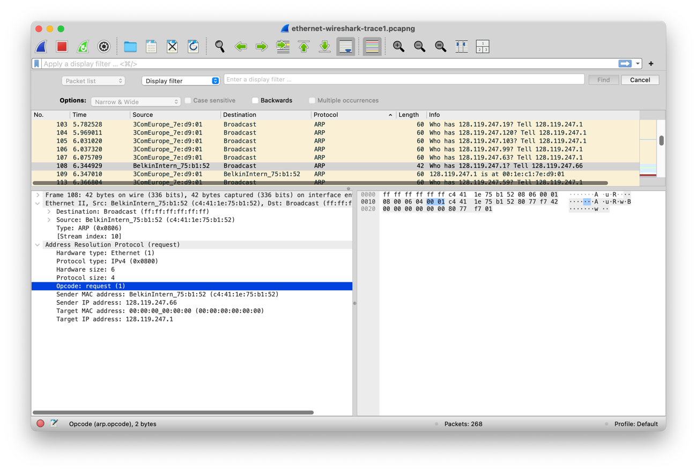

16. What is the value of the opcode field within the ARP request message sent by your computer?

* The **value is 1**, indicates the operation is for request.

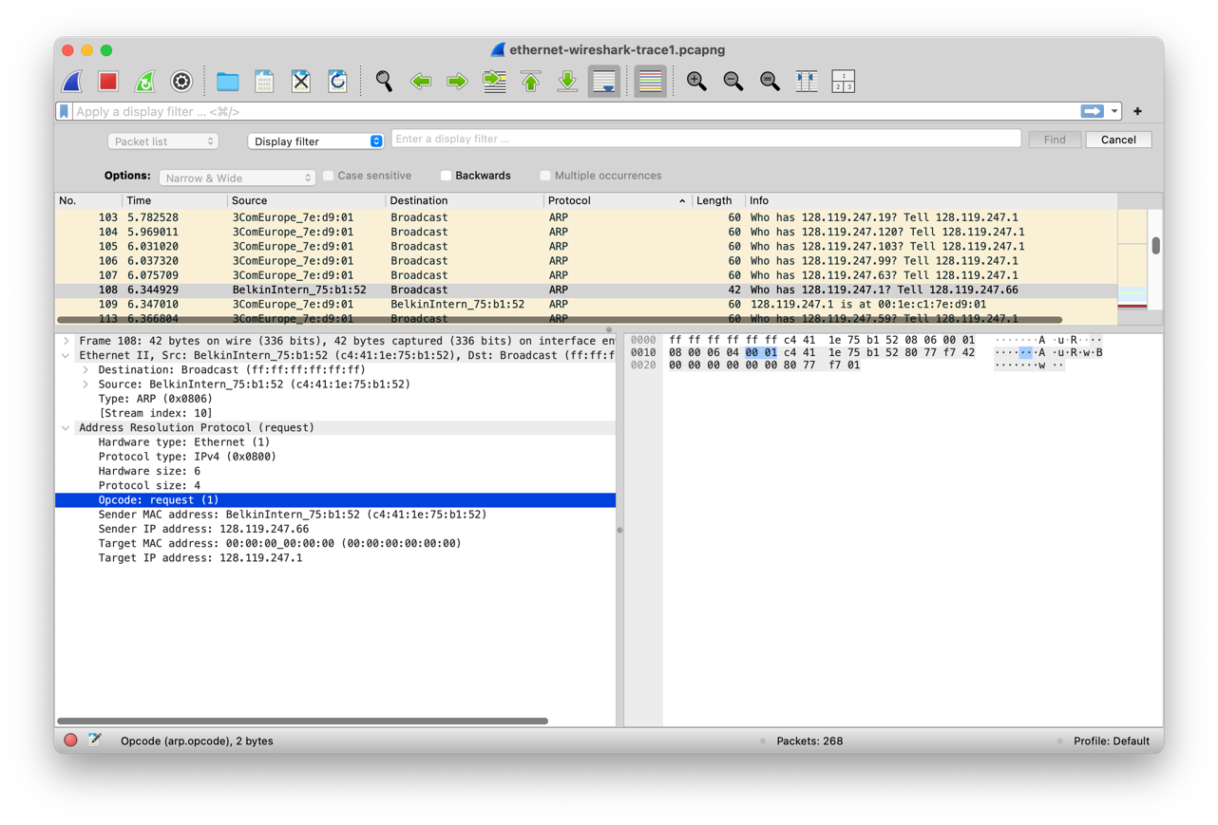

17. Does the ARP request message contain the IP address of the sender? If the answer is yes, what is that value?

* **Yes**, the ARP request message does contain the IP address of the sender.

The IP address is: **128.119.247.66**

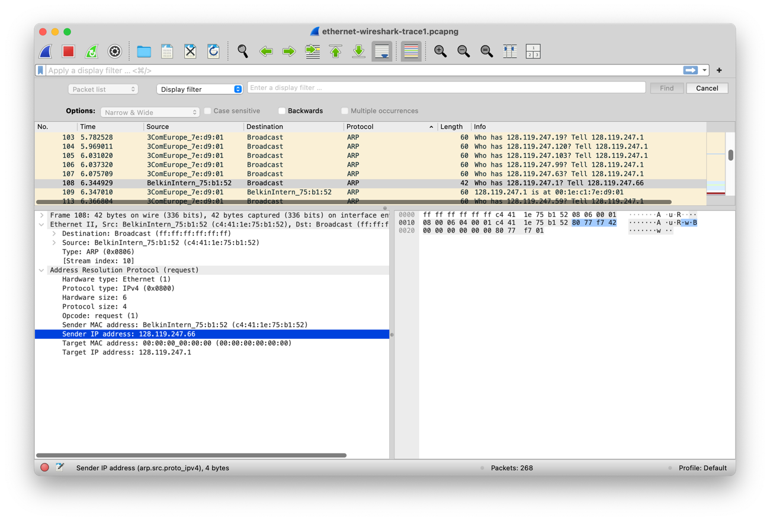

18. What is the IP address of the device whose corresponding Ethernet address is being requested in the ARP request message sent by your computer?

* Target IP address is: **128.119.247.1**

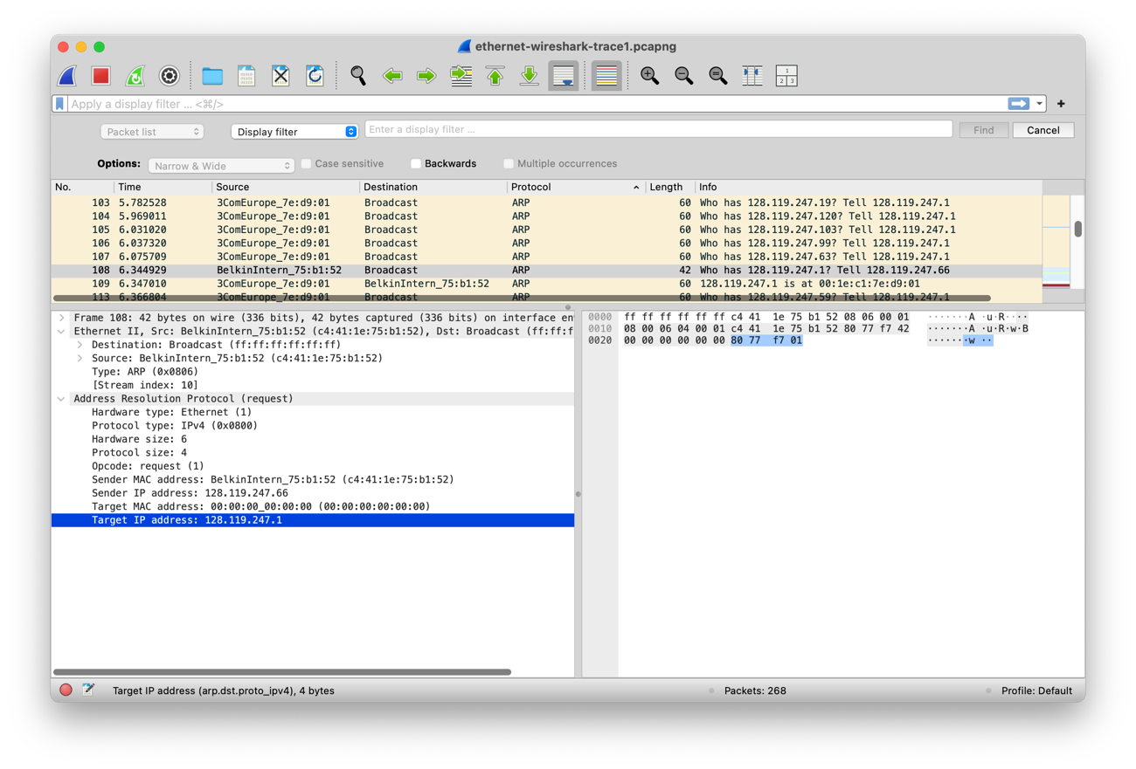

19. What is the value of the opcode field within the ARP reply message received by your computer?

* The **value is 2**, indicates the operation is for request.

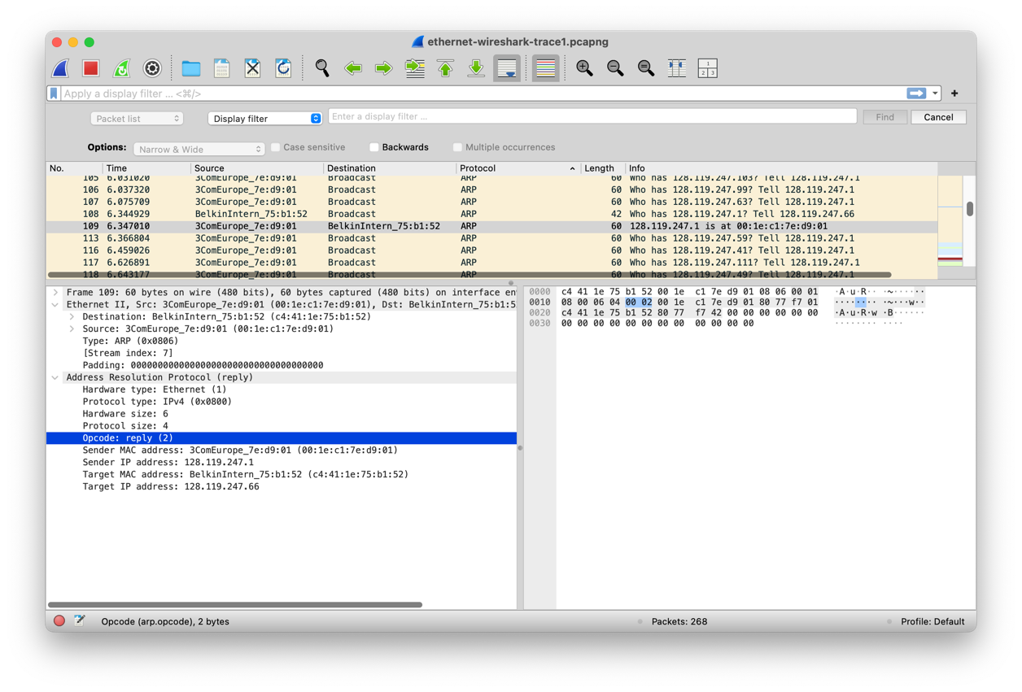

20. Finally (!), let’s look at the answer to the ARP request message! What is the Ethernet address corresponding to the IP address that was specified in the ARP request message sent by your computer (see question 18)?

* The Ethernet address is **00:00:00:00:00:00**, indicates the target MAC address is unknown.

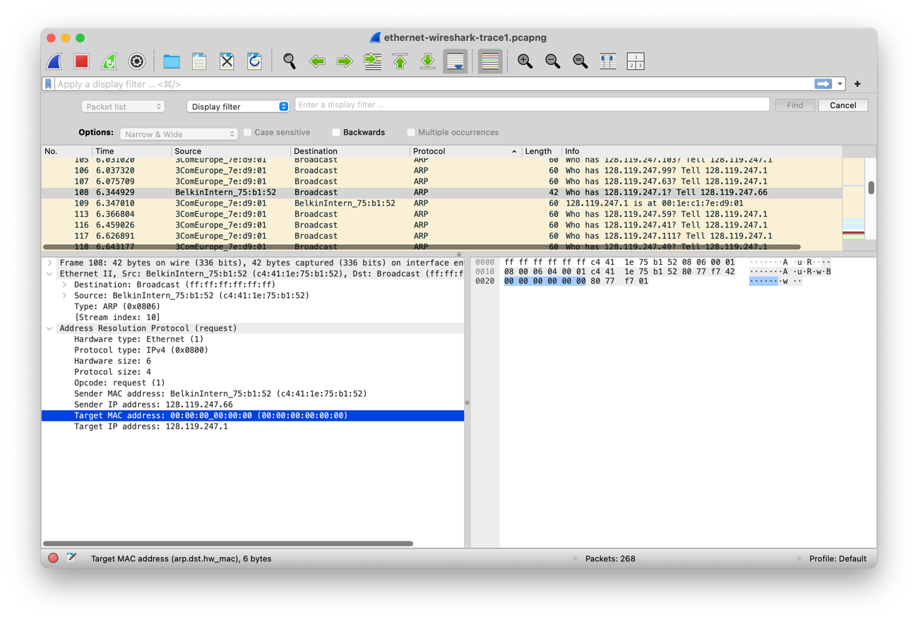

21. We’ve looked the ARP request message sent by your computer running Wireshark, and the ARP reply message sent in response. But there are other devices in this network that are also sending ARP request messages that you can find in the trace. Why are there no ARP replies in your trace that are sent in response to these other ARP request messages?

* While ARP requests are broadcast to all devices on a network, ARP replies are sent only to the specific host that made the original request. We can only see the ARP reply that directly responds to our earlier ARP request.

EX-1. The arp command:

arp -s InetAddr EtherAddr

allows you to manually add an entry to the ARP cache that resolves the IP address InetAddr to the physical address EtherAddr. What would happen if, when you manually added an entry, you entered the correct IP address, but the wrong Ethernet address for that remote interface?

* If manually added an incorrect Ethernet address to ARP cache, the host will send packets to a wrong target device, causing communication failures. We would not be able to access the host successfully. Additionally, This also mimics ARP poisoning, where attackers could inject false information to intercept traffic or disrupt networks. This can be a security risk if exploited maliciously.

EX-2. What is the default amount of time that an entry remains in your ARP cache before being removed? You can determine this empirically (by monitoring the cache contents) or by looking this up in your operating system documentation. Indicate how/where you determined this value.

* The standard time-out for ARP cache is **20 minutes** in macOS.

It seems that the arp utility in macOS is one from OpenBSD, and according to [document provided by Apple](https://opensource.apple.com/source/network_cmds/network_cmds-328/arp.tproj/arp4.4.auto.html), the arp4.4 used in macOS specific that the “routes time out periodically, normally 20 minutes after validated”.

Discussion & Evaluation

* For discussion, the results of this lab provided valuable insights into the structure and behavior of Ethernet frames and ARP messages. By analyzing the captured packets, we could clearly distinguish between different frames and observe the encapsulation of higher-layer protocols. For example, we identified the frame type values and the precise byte locations of key data like the HTTP GET request and ARP responses.
* For evaluating, I think Wireshark proved to be highly effective in visualizing and filtering these frames, making it easy to dissect network communication at various protocol layers. However, the tool comes with risks, particularly regarding privacy and security. As Wireshark captures all network traffic, it can unintentionally expose sensitive data such as usernames, passwords, and confidential information when used in unsecured environments. Moreover, if Wireshark is used improperly or on a shared network without permission, it can be exploited for malicious purposes. Thus, while Wireshark is an excellent tool for network analysis, it must be used responsibly, with proper permissions and safeguards in place to avoid violating privacy and security policies.